Online Time Table
Days / Periods | 9:00a.m – 9:45a.m  I | 9:55a.m – 10:30a.m  II | 10:30a.m – 10:50a.m | 10:50a.m – 11:25a.m  III | 11:35a.m – 12:10p.m  IV
Monday | Hindi  (Ms Archana) | Maths  (Ms Santosh) | BREAK | Computer  (Ms Preeti Madaan) | EVS  (Ms Pradeep)
Tuesday | Hindi | Maths | BREAK | Music  (Ms Sunita) | EVS
Wednesday | Hindi | G.K  (Ms Harkiran) | BREAK | English  (Ms Priyanka Ojha) | EVS
Thursday | Punjabi  (Ms Sukhwinder) | Dance  ( Mr Ravi ) | BREAK | English | EVS
Friday | Punjabi | Maths | BREAK | English | A/C  (Ms Preeti)
Saturday | Punjabi | Maths | BREAK | English | Games
Class – III A Class –III B
Days / Periods | 9:00a.m – 9:45a.m  I | 9:55a.m – 10:30a.m  II | 10:30a.m – 10:50a.m | 10:50a.m – 11:25a.m  III | 11:35a.m – 12:10p.m  IV
Monday | EVS  ( Ms. Pradeep ) | Computer  (Ms Preeti Madaan) | BREAK | Games  ( Ms Shivani ) | Maths  (Ms Preeti Madaan )
Tuesday | EVS | G.K  (Ms. Harkiran) | BREAK | Hindi  ( Ms Archana ) | Punjabi
Wednesday | English  (Ms Ojha) | Dance  ( Mr Ravi ) | BREAK | Hindi | Punjabi
Thursday | English | A/C  ( Ms Preeti ) | BREAK | Punjabi (Ms Jaswinder) | Maths
Friday | English | EVS | BREAK | Hindi | Maths  (Ms Preeti Mdaan)
Saturday | English | EVS | BREAK | Music  (Ms Sunita) | Maths  (Ms Preeti Madaan)
Class –III C
Days / Periods | 9:00a.m – 9:45a.m  I | 9:55a.m – 10:30a.m  II | 10:30a.m – 10:50a.m | 10:50a.m – 11:25a.m  III | 11:35a.m – 12:10p.m  IV
Monday | Maths  (Ms Ojha) | Hindi  (Ms Archana) | BREAK | English | G.K  ( Ms Harkiran )
Tuesday | Maths | Hindi | BREAK | Punjabi  ( Ms Sukhwinder ) | English
Wednesday | EVS  (Ms Jyoti) | Games  ( Ms Shivani | BREAK | Punjabi | Dance
Thursday | EVS | Computer  (Ms Preeti Madaan) | BREAK | Music  ( Ms Sunita ) | Punjabi
Friday | Hindi | English  (Ms Ojha) | BREAK | EVS  (Ms Jyoti) | Maths
Saturday | A/C  (Ms Preeti ) | English | BREAK | EVS | Maths
Days / Periods | 9:00 a.m – 9:45a.m  I | 9:55 a.m – 10:30a.m  II | 10:30 a.m – 10:50a.m | 10:50 a.m – 11:25a.m  III | 11:35 a.m – 12:10 p.m  IV
Monday | Computer  (Ms Kamal) | English  ( Ms Neelima ) | BREAK | Music  (Ms Sunita ) | Punjabi
Tuesday | G.K  (Ms Harkiran) | Maths  ( Ms Priyanka Ojha ) | BREAK | Dance  ( Mr Ravi ) | English
Wednesday | EVS  (Ms Pradeep) | Maths | BREAK | Games  (Ms Shivani) | Hindi
Thursday | EVS | Maths | BREAK | Punjabi  ( Ms Sukhwinder ) | Maths
Friday | EVS | English  (Ms Neelima) | BREAK | Punjabi | Hindi
Saturday | EVS | English | BREAK | Hindi  ( Ms Archana ) | A/C  (Ms Jyoti)
Online Time Table
Days / Periods | 9:00a.m – 9:45a.m  I | 9:55a.m – 10:30a.m  II | 10:30a.m – 10:50a.m | 10:50a.m – 11:25a.m  III | 11:35a.m – 12:10 p.m  IV
Monday | English  (Ms Neelima) | Music  ( Ms Sunita ) | BREAK | G.K  (Ms Harkiran) | Maths  (Ms Santosh)
Tuesday | Punjabi (Ms Sukhwinder) | English | BREAK | EVS  ( Ms Harkiran ) | Maths
Wednesday | Punjabi | English | BREAK | Hindi | Maths
Thursday | Games  (Ms Shivani ) | English | BREAK | EVS | Maths
Friday | Hindi  ( Ms Neelam ) | Computer  (Ms Preeti Madaan ) | BREAK | EVS | Dance  (Mr. Ravi)
Saturday | Hindi | A/C  (Ms Jyoti) | BREAK | Punjabi | EVS
Class – IV B Class –IV C
Days / Periods | 9:00a.m – 9:45a.m  I | 9:55a.m – 10:30a.m  II | 10:30a.m – 10:50a.m | 10:50a.m – 11:25a.m  III | 11:35a.m – 12:10p.m  IV
Monday | Punjabi (Ms Jaswinder) | G.K  (Ms Harkiran) | BREAK | Dance  ( Mr Ravi ) | A/C  (Ms Jyoti)
Tuesday | Hindi (Ms Anupama) | Punjabi | BREAK | EVS | Music  ( Ms Sunita )
Wednesday | Hindi | Maths | BREAK | EVS | English  (Ms Neelima)
Thursday | Hindi | Maths | BREAK | Punjabi | English
Friday | Maths  (Ms Santosh) | EVS  ( Ms Kamal ) | BREAK | Computer  ( Ms Kamal ) | English
Saturday | Maths | EVS | BREAK | Games  ( Ms Shivani ) | English
Class –V A
Days / Periods | 9:00a.m – 9:45a.m  I | 9:55a.m – 10:30a.m  II | 10:30a.m – 10:50a.m | 10:50a.m – 11:25a.m  III | 11:35a.m – 12:10p.m  IV
Monday | Maths  (Ms Santosh) | Punjabi ( Ms Sukhwinder ) | BREAK | English  (Ms Neelima) | Hindi  (Ms Archana)
Tuesday | Maths | EVS  (Ms Kamal) | BREAK | English | Hindi
Wednesday | Maths | EVS | BREAK | English | Music  (Ms Sunita)
Thursday | Maths | EVS | BREAK | A/C  ( Ms Jyoti ) | Dance  ( Mr Ravi )
Friday | EVS | Punjabi | BREAK | G.K  ( Ms Pradeep ) | Games  (Mr Rahul)
Saturday | English | Punjabi | BREAK | Computer  ( Ms Kamal ) | Hindi
Days / Periods | 9:00a.m – 9:45a.m  I | 9:55a.m – 10:30a.m  II | 10:30a.m – 10:50a.m | 10:50a.m – 11:25a.m  III | 11:35a.m – 12:10p.m  IV
Monday | Music  ( Ms Sunita ) | A/C  ( Ms Jyoti ) | BREAK | Maths  (Ms Santosh) | EVS  (Ms Kamal)
Tuesday | English  ( Ms Neelima ) | Punjabi ( Ms Sukhwinder ) | BREAK | Maths | EVS
Wednesday | English | Hindi  ( Ms Archana ) | BREAK | Maths | EVS
Thursday | English | Hindi | BREAK | Maths | EVS
Friday | English | Hindi | BREAK | Games  ( Mr Rahul ) | Punjabi
Saturday | Computer  (Ms Kamal ) | Dance  ( Ms Ravi ) | BREAK | G.K  (Ms Pradeep) | Punjabi

Online Time Table
Class VI Class VI
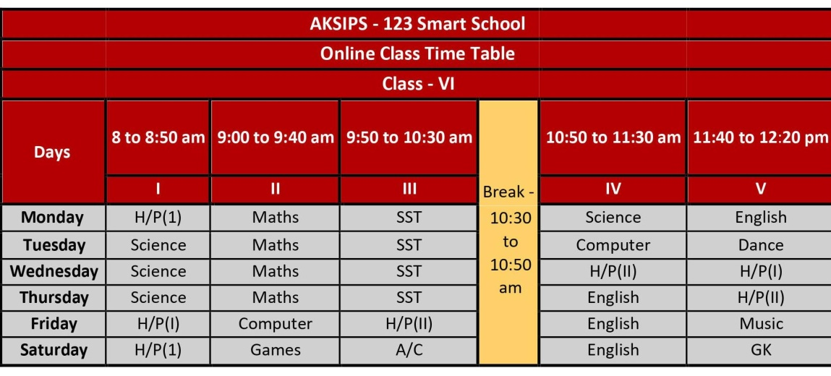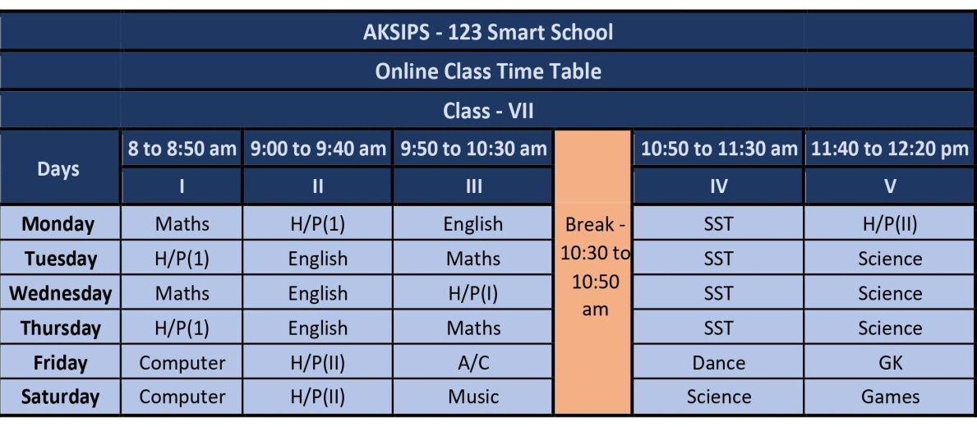

Class VIII Class IX
