Syllabus Bifurcation Session 2021-2022
Class VI

MATHEMATICS

TERM I
APRIL TO MAY
Chapter 1 Knowing Our Numbers
Chapter 2 Whole Numbers
Chapter 3 Playing with Numbers
Chapter 4 Basic Geometrical Ideas

JULY TO SEPTEMBER
Chapter 5 Understanding Elementary Shapes
Chapter 6 Integers
Chapter 7 Fractions
Chapter 8 Decimals

TERM II

OCTOBER TO DECEMBER
Chapter 9 Data Handling
Chapter 10 Mensuration
Chapter 11 Algebra
Chapter 13 Symmetry

JANUARY TO MARCH
Chapter 12 Ratio and Proportion
Chapter 14 Practical Geometry

SCIENCE
TERM-1
APRIL to MAY
Chapter-1 Food: Where does it come from?
Chapter-2 Components of Food
Chapter-3 Fibre to Fabric
Chapter-13 Fun with magnets

JULY to SEPTEMBER
Chapter- 4 Sorting materials into groups
Chapter-5 Separation of Substances
Chapter-10 Motion and Measurement of Distances
Chapter- 7 Getting to know plants

TERM-2
OCTOBER to DECEMBER
Chapter- 6 Changes around us
Chapter- 8 Body movements
Chapter-9 The Living organisms and their surroundings
Chapter 11 Light, Shadow and Reflection
Chapter- 14 Water

JANUARY to MARCH
Chapter- 12 Electricity and Circuits
Chapter-15 Air around us
Chapter- 16 Garbage in, Garbage out

PUNJABI 1ST LANGUAGE

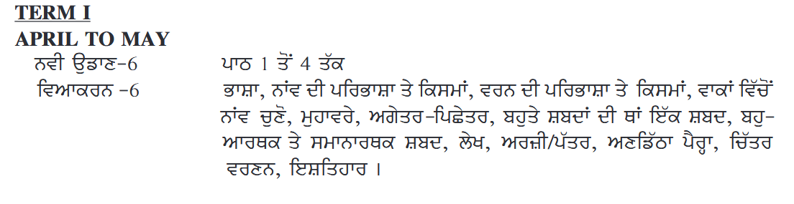
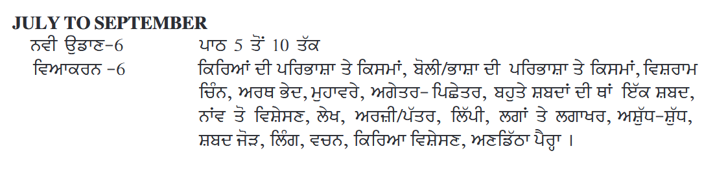
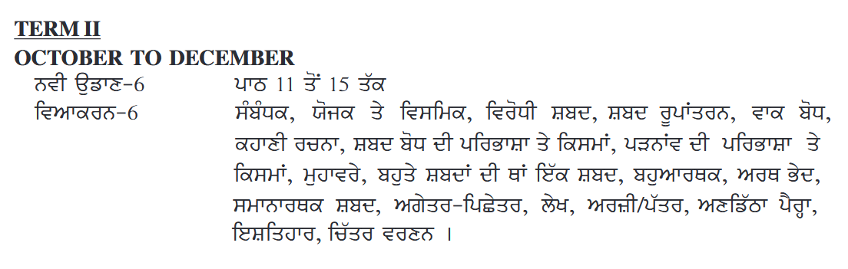

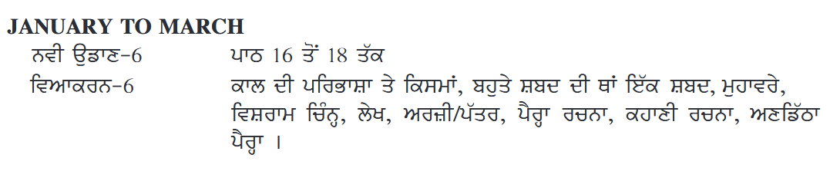

PUNJABI 2ND LANGUAGE(AKSIPS 123 & 65)
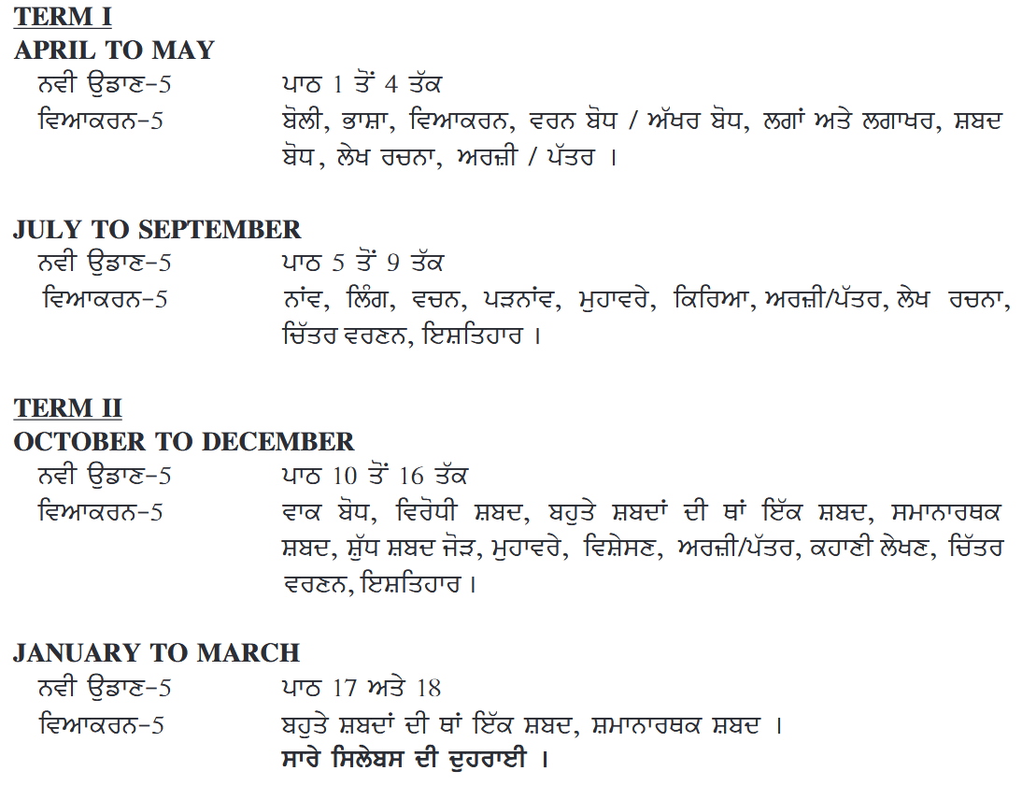

SOCIAL SCIENCE
History
TERM –I
APRIL TO MAY
Chapter 1 – What, Where, How And When?
Chapter 2 – From Hunting – Gathering To Growing Food
Chapter 3 – In The Earliest Cities
JULY TO SEPTEMBER
Chapter 4 – What Books And Burials Tell Us
Chapter 5 – Kingdoms, Kings And An Early Republic
Chapter 6 – New Questions And Ideas
Chapter 7 – Ashoka, The Emperor Who Gave Up War
TERM II
OCTOBER TO DECEMBER
Chapter 8 – Vital Villages, Thriving Towns
Chapter 9 – Traders, Kings And Pilgrims
Chapter 10 – New Empires And Kingdoms
JANUARY TO MARCH
Chapter 11 – Buildings, Paintings And Books
CIVICS
TERM –I
APRIL TO MAY

Chapter 1 – Understanding Diversity
Chapter 2 – Diversity and Discrimination
Chapter 3 – What is Government?
JULY TO SEPTEMBER

Chapter 4 – Key Elements of a Democratic Government
Chapter 5 – Panchayati Raj
TERM II
OCTOBER TO DECEMBER

Chapter 6 – Rural Administration
Chapter 7 – Urban Administration
Chapter 8 – Rural Livelihoods
JANUARY TO MARCH

Chapter 9 – Urban Livelihoods
Geography
TERM –I
APRIL TO MAY
Chapter 1 – The Earth in the Solar System
Chapter 2 – Globe: Latitudes and Longitudes
JULY TO SEPTEMBER
Chapter 3 – Motions of the Earth
Chapter 4 – Maps
TERM II
OCTOBER TO DECEMBER

Chapter 5 – Major Domains of the Earth
Chapter 6 – Major Landforms of the Earth
Chapter 7 – Our Country: India
JANUARY TO MARCH
Chapter 8 – India: Climate, Vegetation and Wildlife

English
TERM I
APRIL TO MAY
Literature Reader
Unit 1 The Why - Why Girl
Unit 2 A Hero
Unit 3 I Asked The Little Boy Who Cannot See
LANGUAGE
1. Articles
2. Notice Writing (Lost & Found)
3. Short Story Writing
4. Comprehension Passages
Novel: Lesson 1 & 2
JULY TO SEPTEMBER
Literature Reader
Unit 4 The King of the Polar Bears
Unit 5 I Wish
Unit 6 Houdini’s Challenge
LANGUAGE
1. Paragraph Writing
2. Adjectives
3. Informal Letter Writing
4. Comprehension Passages
5. Subject - Verb Agreement
6. Tenses (Simple Present, Simple Past, Simple Future)
* Integrated Grammar Practice to be done as per the Grammar topics.
Novel: Lesson 3 & 4
TERM II
OCTOBER TO DECEMBER
Literature Reader
Unit 7 The Giant
Unit 8 Ju’s Story
Unit 9 William the Helper
Unit 10 Tiger
LANGUAGE
1. Prepositions
2. Diary Entry (50-60 words)
3. Adverbs
4. Modals
5. Comprehension Passages
6. Active Passive Voice
7. Application to the Principal
* Integrated Grammar Practice to be done as per the Grammar topics.
Novel: Lesson 5 & 6
JANUARY TO MARCH
Literature Reader
Unit 11 The Giraffe and the Pelly and Me
Unit 12 Leisure
Unit 13 A Christmas Carol
LANGUAGE
1. Article Writing
2. Comprehension Passages
3. Conjunctions
4. Reported Speech (Statements)
Novel: Lesson 7

Computer

TERM –I
APRIL TO MAY
1. Computer – Its Components
2. Computer Memory
JULY TO SEPTEMBER
3. Excel – Creating Worksheet
4. Excel – Formula and Function
5. Excel – Creating Charts
TERM –II
OCTOBER TO DECEMBER
6. Adobe Animate - Introduction
7. Adobe Animate – Drawing Tools
8. Windows Movie Maker

JANUARY TO MARCH
9. Google Apps
10. Internet Service and Safety

Hindi 2nd Language (For AKSIPS 123 & 65)

GENERAL KNOWLEDGE

TERM-1
APRIL to MAY
UNIT 1 ( INDIA AND THE WORLD)
Chapter 1 to 5
UNIT 2 (ENVIRONMENT AND ECOLOGY)
Chapter 6 to 8
JULY to SEPTEMBER
UNIT 2 (ENVIRONMENT AND ECOLOGY)
Chapter 9 to 10
Recall-1
UNIT 3 (SCIENCE AND TECHNOLOGY)
Chapter 11 to 15

TERM-2

OCTOBER to DECEMBER
UNIT 4 (ENTERTAINMENT)
Chapter 16 to 18
Recall-2
Quick Quiz-1
UNIT 5( LITERATURE , LANGUAGE AND ART)
Chapter 19to 23
UNIT 6 (SPORTS)
Chapter 24 to 28
Recall- 3

JANUARY to MARCH
UNIT 7(REASONING & NUMBER SKILLS)
Chapter 29 to 31
UNIT 8 (POTPOURRI)
Chapter 32 to 36
Recall-4
Quick Quiz-2

ART AND CRAFT
TERM I
APRIL TO MAY
- Tools of Drawing
- Element of Drawing
- Perspective
- Light & Shade
- Still Life Drawing

JULY TO SEPTEMBER
- Nature Drawing
- Decorative Design
- Human Figure
- T-Shirt Design

TERM II
OCTOBER TO DECEMBER
- Cartoons
- Poster Making
- Leaf Impression
- Mehandi Design
- Paper Collage

JANUARY TO MARCH
- Fashion & Beauty
- Dot Painting
- Decoration

MUSIC
TERM I
APRIL TO MAY
- General Aims and Objectives of Music
- Definition of Shruti
- History and Diagram of Flute
- Deep Chandi taal / Ektaal

JULY TO SEPTEMBER
- Music Therapy and its Importance
- Difference between Swar and Shruti
- Elements of Music

TERM II
OCTOBER TO DECEMBER
  - Classification of Swar and Shruti
  - Benefits of Music Education in Child Development.

JANUARY TO MARCH
Various songs to be done throughout the year like School Song, National Anthem, School Prayer, Hindi Prayers, English Prayers, Patriotic Songs, Gazals, Geet, Shabad, Bhajan, General Songs, Folk Songs, Festival Songs etc. according to the festivals. occasions coming in various months.

DANCE

TERM I
APRIL TO MAY
- Elements of Dance.
- Movement of different parts of the body.
- Definition of Expressions.

JULY TO SEPTEMBER
- Importance of Expression in Dance.
- Creation of dance on a popular song (Western/Folk/Bollywood)

TERM II
OCTOBER TO DECEMBER
- Explanation of emotions with respect to song.
- Names of Navras
- Similarities of semi classical and contemporary dance forms.

JANUARY TO MARCH
- Importance of Rhythm in dance
- Various dances to be done throughout the year like Western Dances, Folk Dances, Patriotic Dances, Semi-Classical Dances, Contemporary Dances etc. related to the festivals/occasions coming in various months.

CLASS 7
ENGLISH
TERM I
APRIL TO MAY
Literature Reader
Unit 1 The Pterodactyl’s Egg
Unit 2 The Eagle
Unit 3 The Reader of Books
LANGUAGE
1. Determiners
2. Prepositions
3. Diary Entry
4. Informal Letter Writing
5. Comprehension Passages
Novel Chapters 1 to 3
JULY TO SEPTEMBER
Literature Reader
4 The Plaint of the Camel
5 Yan’s Quest
6 The Blue Umbrella
BBC
1. Adverbs
2. Adjectives
3. Notice Writing
4. Article Writing
5. Tenses
6. Editing
* Integrated Grammar Practice to be done as per the Grammar topics.
Novel Chapters 4 to 6
TERM II
OCTOBER TO DECEMBER
Literature Reader
Unit 7 Daybreak Unit
Unit 8 A Lesson in the Henhouse
Unit 9 The Walking Stick Story
Unit 10 Autumn in the Hills
BBC
1. Modals
2. Voice
3. Formal letter (Letters to Editor)
4. Comprehension Passages
Novel Chapters 7 to 9
JANUARY TO MARCH
Literature Reader
Unit 11 The Footsteps Die Out For Ever
Unit 12 The Bangle Sellers
Unit 13 The Comedy of Errors
BBC
1. Narration (Reported Speech-Statements and Questions)
2. Conjunctions
3. Short Story Writing
* Integrated Grammar Practice to be done as per the Grammar topics.
Novel Chapters 10 & 11

MATHEMATICS

TERM I
APRIL TO MAY
CHAPTER 1 Integers
CHAPTER 2 Fractions and Decimals
CHAPTER 9 Rational Numbers
CHAPTER 5 Lines and Angles

JULY TO SEPTEMBER
CHAPTER 12 Algebraic Expressions
CHAPTER 13 Exponents and Powers
CHAPTER 4 Simple Equations
CHAPTER 6 The Triangle and its Properties

TERM II
OCTOBER TO DECEMBER
CHAPTER 3 Data Handling
CHAPTER 7 Congruence of Triangles
CHAPTER 8 Comparing Quantities
CHAPTER 10 Practical Geometry

JANUARY TO MARCH
CHAPTER 11 Perimeter and Area
CHAPTER 14 Symmetry
CHAPTER 15 Visualizing Solid Shapes

Social Science

History
TERM 1
APRIL TO MAY
Chapter 1: Tracing Changes through a Thousand Years
Chapter 2: New Kings and Kingdoms
JULY TO SEPTEMBER
Chapter 3: The Delhi Sultans
Chapter 4: The Mughal Empire
Chapter 5: Rulers and Buildings
TERM II
OCTOBER TO DECEMBER
Chapter 6: Towns, Traders and Craftspersons
Chapter 7: Tribes, Nomads and Settled Communities
Chapter 8: Devotional Paths to the Divine

JANUARY TO MARCH
Chapter 9: The Making of Regional Cultures
Chapter 10: Eighteenth Century Political Formations

CIVICS
TERM 1
APRIL TO MAY

UNIT 1 Equality in Indian Democracy
Chapter 1: On Equality
UNIT II State Government
Chapter 2: Role of the Government in Health
Chapter 3: How the State Government Works
JULY TO SEPTEMBER
UNIT III Gender
Chapter 4: Growing up as Boys and Girls
Chapter 5: Women Change the World
TERM II
OCTOBER TO DECEMBER
UNIT IV Media and Advertising
Chapter 6: Understanding Media
UNIT V Markets
Chapter 7: Markets Around Us
JANUARY TO MARCH
Chapter 8: A Shirt in the Market
Chapter 9: Struggles for Equality

Geography
TERM 1
APRIL TO MAY
Chapter 1: Environment
Chapter 2: Inside Our Earth
JULY TO SEPTEMBER
Chapter 3: Our Changing Earth
Chapter 4: Air
Chapter 5: Water
TERM II
OCTOBER TO DECEMBER
Chapter 6: Natural Vegetation and Wildlife
Chapter 7: Human Environment – Settlement, Transport and Communication
Chapter 8: Human Environment Interactions – The Tropical and the Subtropical Region
JANUARY TO MARCH
Chapter 9: Life in the Deserts

SCIENCE
TERM –I
APRIL TO MAY
Chapter 1 - Nutrition in Plants
Chapter 2 – Nutrition in Animals
Chapter 3 - Fibre to Fabric
Chapter 4 - Heat
Chapter 5 – Acids, Bases and Salts

JULY TO SEPTEMBER
Chapter 6 - Physical and Chemical Changes
Chapter 7 - Weather , Climate and Adaptation
Chapter 8 - Winds , Storms and Cyclones
Chapter 13 - Motion and Time

TERM –II
OCTOBER TO DECEMBER
Chapter 9 - Soil
Chapter 10 - Respiration in Organism
Chapter 11 - Transportation in Animals & Plants
Chapter 12 - Reproduction in Plants
Chapter 14 - Electric Current and its Effect

JANUARY TO MARCH
Chapter 15 - Light
Chapter 16 - Water – A precious Resource
Chapter 17 - Forest : Our Lifeline
Chapter 18 - Waste Water Story

GENERAL KNOWLEDGE

TERM-1
APRIL to MAY
UNIT 1 ( INDIA AND THE WORLD)
Chapter 1 to 5
UNIT 2 (ENVIRONMENT AND ECOLOGY)
Chapter 6 to 8
JULY to SEPTEMBER
UNIT 2 (ENVIRONMENT AND ECOLOGY)
Chapter 9 to 10
Recall-1
UNIT 3 (SCIENCE AND TECHNOLOGY)
Chapter 11 to 15

TERM-2
OCTOBER to DECEMBER
UNIT 4 (ENTERTAINMENT)
Chapter 16 to 18
Recall-2
Quick Quiz-1
UNIT 5( LITERATURE, LANGUAGE AND ART)
Chapter 19to 23
UNIT 6 (SPORTS)
Chapter 24 to 28
Recall- 3
JANUARY to MARCH
UNIT 7(REASONING & NUMBER SKILLS)
Chapter 29 to 31
UNIT 8 (POTPOURRI)
Chapter 32 to 36
Recall-4
Quick Quiz-2

COMPUTER
TERM –I
APRIL TO MAY
1. Computer Virus
2. Number System

JULY TO SEPTEMBER
3. Animate – Layers & Animation
4. Photoshop - Introduction
5. Photoshop – Layers & Filters

TERM –II
OCTOBER TO DECEMBER
6. Internet – Ethics & Safeguard
7. HTML - Introduction
8. HTML – Creating Web Page

JANUARY TO MARCH
9. HTML – Images , Links & Tables
10 Access – Creating a Database

ART AND CRAFT
TERM I
APRIL TO MAY
1. Types of Drawing
2. Perspective
3. Composition
4. Texture
5. Salt Art

JULY TO SEPTEMBER
1. Nature Drawing
2. Human Anatomy
3. African Mask Art

TERM II
OCTOBER TO DECEMBER
1. Fashion Designing
2. Landscape
3. Cartoon Making
4. Photo Collage

JANUARY TO MARCH
1. Puppetry
2. Greeting Card

Dance
Term-1
APRIL To MAY
1.Knowledge of contemporary dance form.
2.Benefits of dance.

JULY TO SEPTEMBER
1.Definition of choreography.
2.Knowledge of free style dances.

Term-ll
OCTOBER TO DECEMBER
1.Fundamental and History of HIP-HOP
2.Definition of Folk Dance.

JANUARY TO MARCH
1. Knowledge of Modern Dance.
2.Various dances to be done throughout the year like western dances, folk dances, patriotic dances, semi-classical dances, contemporary dances etc. related to the festival/occasions coming in various months.

Music

TERM-I
APRIL-MAY
1.Definition of Orchestra.
2. Definition and Background of Folk Music.
3. Discuss Folk Instruments of various states.

JULY-SEPTEMBER
1.Features and Importance of Folk Music.
2. Difference between Folk Music, Light Music and Film Music.
3. Any raag comprising Aroh, Avroh, Pakad and Bandish.

TERM-II
OCTOBER-DECEMBER
1. Definition and Classification of Scale/Octave.
2.Knowledge of Vadi, Samvadi and Varjit Swar.
3. Diagram and History of Tanpura.

JANUARY - MARCH
Various songs to be done throughout the year like School song, National Anthem, School Prayer, Hindi Prayers,English Prayers, Patriotic songs, Gazals, Geet, Shabad, Bhajan, General songs, Folk songs, Festival songs etc. According to the festivals/occasions coming in various months.

Hindi lst Language
Term l
APRIL TO MAY
वसंत (भाग - 2) पाठ 1से 4 तक
बाल महाभारत कथा - ‘महाभारत कथा ' से 'लाख का घर ' तक
नवतरंग हिन्दी व्याकरण - 7 पाठ - 1, संज्ञा तथा भेद , लिंग , विलोम ( 1 से 10 ), पर्यायवाची ( 1 से 12 ), वाक्यांश ( 1 से 12 ), स्वर संधि ( दीर्घ ), पत्र ,अनुच्छेद, चित्र वर्णन ,अपठित गद्यांश ।

JULY TO SEPTEMBER
वसंत ( भाग - 2 ) पाठ 5 से 10 तक
बाल महाभारत कथा - पांडवों की रक्षा से मायावी सरोवर तक
नवतरंग हिन्दी व्याकरण - 7 पाठ - 2 ( वर्ण विचार ) , अनेकार्थी ( 1 से 15 ), विलोम (11 से 20 ), पर्यायवाची ( 13 से 24 ) ,विशेषण , स्वर संधि (गुण व वृद्धि ) मुहावरे ( 1 से 20 ) , उपसर्ग ,प्रत्यय , क्रिया ( अकर्मक / सकर्मक ) , पत्र , शब्द विचार,अनुच्छेद , संवाद व सूचना लेखन ।

TERM ll
OCTOBER TO DECEMBER
वसंत ( भाग - 2 ) पाठ 11 से 16 तक
बाल महाभारत कथा - ' यक्ष प्रश्न से ' दूसरा और तीसरा दिन तक
नवतरंग हिन्दी व्याकरण - 7 - अविकारी शब्द , वचन , लोकोक्तियाँ (1 से 15 ) , वाक्यांश ( 25 से 36 ) , अनेकार्थक ( 16 से 30 ) , तत्पुरुष समास , मौखिक अभिव्यक्ति,पत्र , अनुच्छेद , अपठित गद्यांश

JANUARY TO MARCH
वसंत ( भाग - 2 ) पाठ - 17 से 20
बाल महाभारत कथा - ' चौथा , पाँचवा और छठा दिन से श्री कृष्ण और युधिष्ठिर ' तक
नवतरंग हिन्दी व्याकरण - 7 विराम चिह्न , अशुद्ध वाक्य , विलोम ( 31 से 40 ) अयादि संधि , कारक ,काल, पर्यायवाची ( 37 से 48 ) , वाक्यांश ( 37 से 48 ) , पुनरावृत्ति , पत्र , अनुच्छेद , अपठित गद्यांश , संवाद लेखन , कहानी लेखन ।

Hindi 2nd Language(For AKSIPS-65& AKSIPS-123)
Term-1
April to May
वसंत (भाग- 1) पाठ 1 से 4 तक
नव तरंग-6(व्याकरण)-भाषा और व्याकरण, वर्ण विचार, पर्यायवाची शब्द, संज्ञा, उपसर्ग /प्रत्यय, अपठित गद्यांश,संवाद लेखन, पत्र लेखन, अनुच्छेद लेखन।

July to September
वसंत भाग- 1- पाठ 5 से 9 तक

नवतरंग -6(व्याकरण)- लिंग ,वचन , सर्वनाम, काल, विशेषण, पत्र लेखन, अनुच्छेद लेखन, अपठित गद्यांश, संवाद लेखन।

Term ll
October to December
वसंत भाग -1 -पाठ 10 से 14 तक
नवतरंग -6(व्याकरण): विराम चिन्ह, मुहावरे ,अपठित गद्यांश ,पत्र लेखन, अनुच्छेद लेखन ।
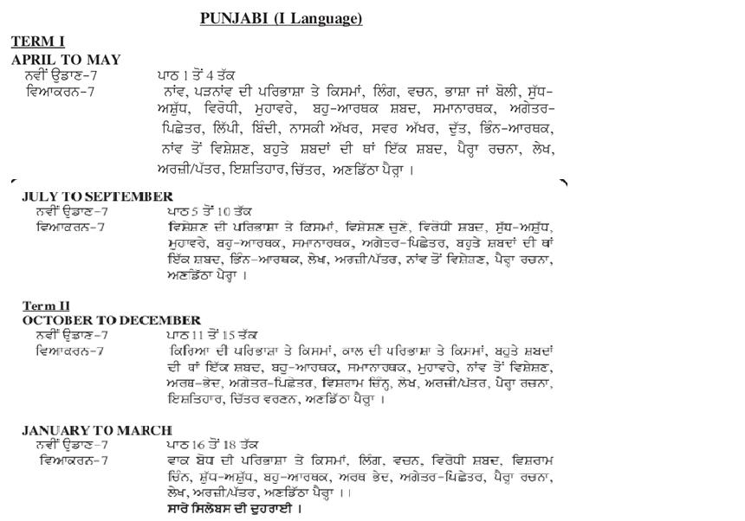

CLASS 8
ENGLISH
TERM I
APRIL TO MAY
Literature Reader
Unit 1 The Passive Voice
Unit 2 Stopping by Woods on a Snowy Evening
Unit 3 A Slight Misunderstanding
BBC
1. Determiners
2. Tenses
3. Notice Writing
4. Informal Letter Writing
5. Comprehension Passages
Novel Chapters 1 to 3
JULY TO SEPTEMBER
Literature Reader
Unit 4 The Song of the Whale
Unit 5 The Station
Unit 7 A Helping Hand
BBC
1. Modals
2. Diary Entry
3. Article Writing
4. Voice
* Integrated Grammar Practice to be done as per the Grammar topics.
Novel Chapters 4 to 6
TERM II
OCTOBER TO DECEMBER
Literature Reader
Unit 6 The Peacock
Unit 8 Thank You, Ma’am
Unit 9 Old Toys and New Magic
Unit 10 It Couldn’t Be Done
BBC
1. Poster Making
2. Conjunctions
3. Formal letters (Letters to Editor & Enquiry Letter)
4. Non-Finites
5. Prepositions
* Integrated Grammar Practice to be done as per the Grammar topics.
Novel Chapters 7 to 9
JANUARY TO MARCH
Literature Reader
Unit 11 Trail of the Green Blazer
Unit 12 The Death of Caesar
Unit 13 The Guest House
BBC
1. Reported Speech
2. Speech Writing
3. Short Story Writing
* Integrated Grammar Practice to be done as per the Grammar topics.
Novel Chapters 10 to 12

SOCIAL SCIENCE
History
TERM 1 APRIL TO MAY
Chapter 1 How, When and Where
Chapter 2 From Trade to Territory The Company Establishes Power
Chapter 3 Ruling the Countryside
JULY TO SEPTEMBER
Chapter 4 Tribals, Dikus and the Vision of a Golden Age
Chapter 5 When People Rebel 1857 and After (Book Part-2)
TERM II OCTOBER TO DECEMBER
Chapter 6 Weavers, Iron Smelters and Factory Owners
Chapter 7 Civilising the “Native”, Educating the Nation
Chapter 8 Women, Caste and Reform
JANUARY TO MARCH
Chapter 9 The Making of the National Movement: 1870s–1947
Chapter 10 India After Independence
CIVICS
TERM 1 APRIL TO MAY
A.UNIT ONE : THE INDIAN CONSTITUTION AND SECULARISM
Chapter 1: The Indian Constitution
Chapter 2: Understanding Secularism
JULY TO SEPTEMBER
B.UNIT TWO: PARLIAMENT AND THE MAKING OF LAWS
Chapter 3: Why do we need a Parliament?
Chapter 4: Understanding Laws
C. UNIT THREE : THE JUDICIARY
Chapter 5: Judiciary
TERM II
OCTOBER TO DECEMBER
Chapter 6: Understanding Our Criminal Justice System
D.UNIT FOUR : SOCIAL JUSTICE AND THE MARGINALISED
Chapter 7: Understanding Marginalisation
Chapter 8: Confronting Marginalisation
JANUARY TO MARCH
E.UNIT FIVE ECONOMIC PRESENCE OF THE GOVERNMENT
Chapter 9: Public Facilities
Chapter 10: Law and Social Justice
Geography
TERM 1 APRIL TO MAY
Chapter 1: Resources
Chapter 2: Land, Soil, Water, Natural Vegetation and Wildlife Resources
JULY TO SEPTEMBER
Chapter 3: Mineral and Power Resources
TERM II OCTOBER TO DECEMBER
Chapter 4: Agriculture
Chapter 5: Industries
JANUARY TO MARCH
Chapter 6: Human Resources

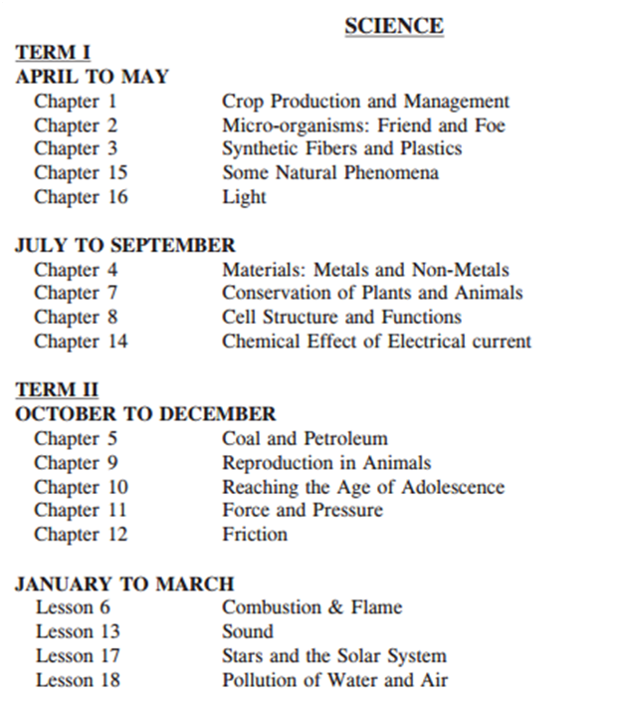

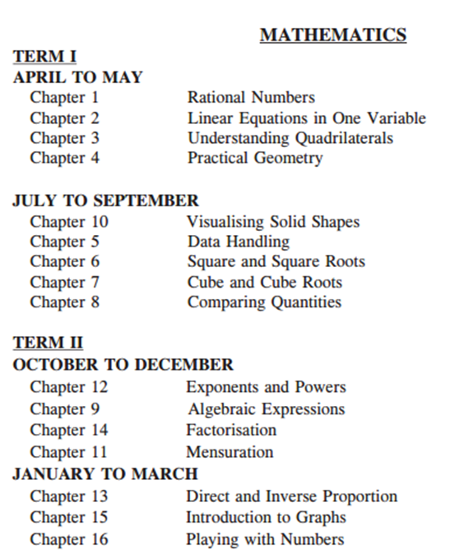

Hindi 1st language
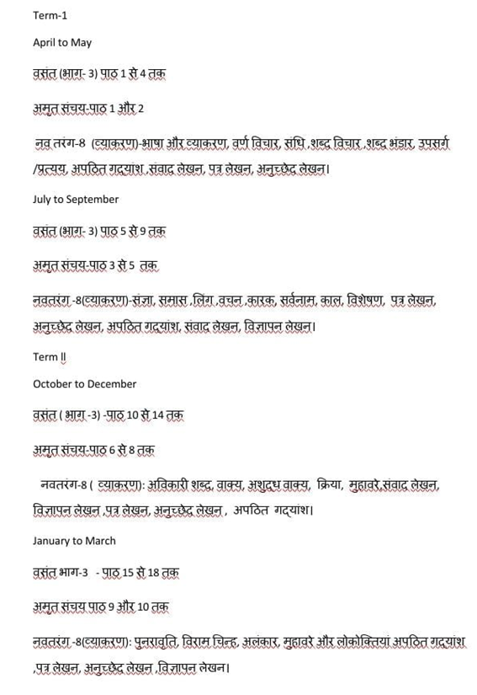

Hindi 2nd Language
Term l
APRIL TO MAY
वसंत (भाग - 2)
पाठ 1 से 4 तक

नवतरंग - 7
पाठ -भाषा और व्याकरण वर्ण विचार, शब्द विचार ,लिंग, वचन,संज्ञा,पत्र ,अनुच्छेद, अपठित गद्यांश ।

JULY TO SEPTEMBER
वसंत ( भाग - 2 ) पाठ 5 से 11 तक
बाल महाभारत कथा - 'पांडवों की रक्षा' से' मायावी सरोवर 'तक
नवतरंग - 7
सर्वनाम व भेद, विलोम, पर्यायवाची शब्द, विशेषण ,अनेकार्थी शब्द, पत्र लेखन , अनुच्छेद लेखन ,अपठित गद्यांश व सूचना लेखन।

TERM ll
OCTOBER TO DECEMBER
वसंत ( भाग - 2 ) पाठ 12 से 16 तक
नवतरंग हिन्दी व्याकरण - 7 -
क्रिया, काल, उपसर्ग/ प्रत्यय, विराम चिन्ह, वाक्यांश, संवाद लेखन, पत्र , अनुच्छेद , अपठित गद्यांश

JANUARY TO MARCH
वसंत ( भाग - 2 ) पाठ - 17 से 20

नवतरंग - 7
अशुद्ध वाक्यों का संशोधन ,अनेकार्थी शब्द श्रुतिसमभिन्नार्थक शब्द, मुहावरे, वाक्य, पत्र , अनुच्छेद , अपठित गद्यांश , संवाद लेखन पुनरावृत्ति , कहानी लेखन ।

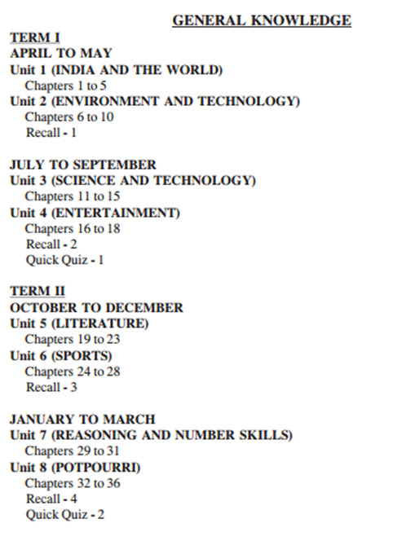
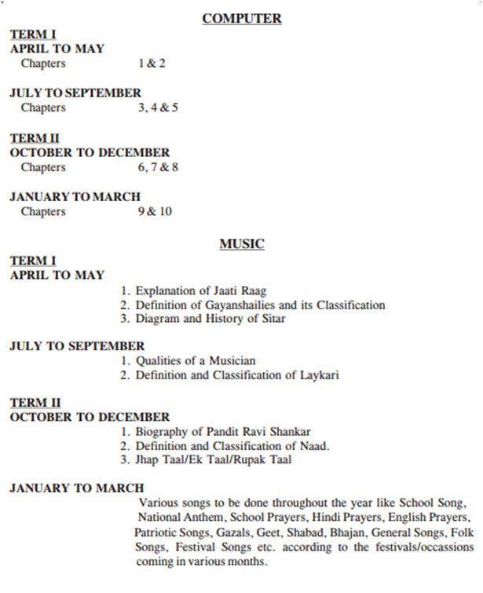

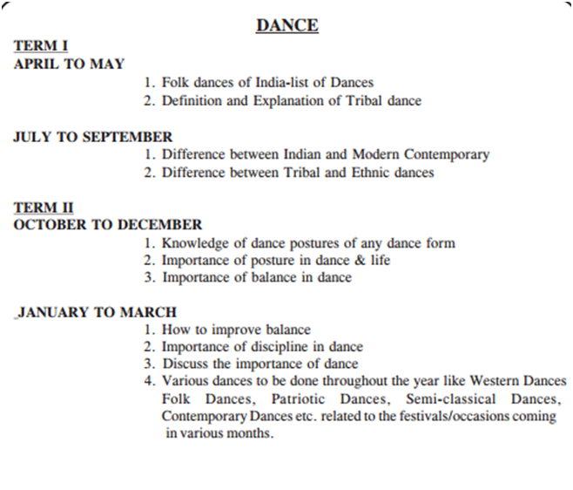
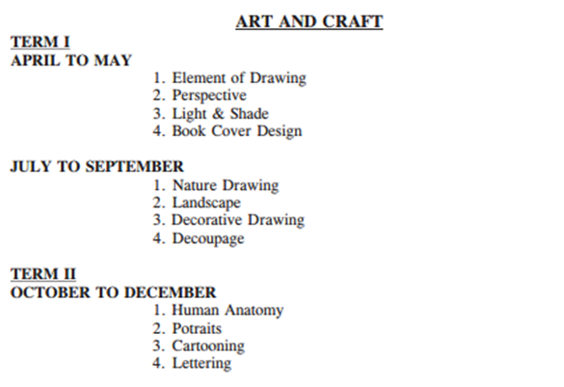
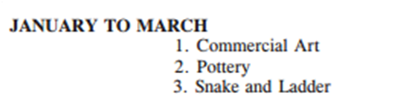

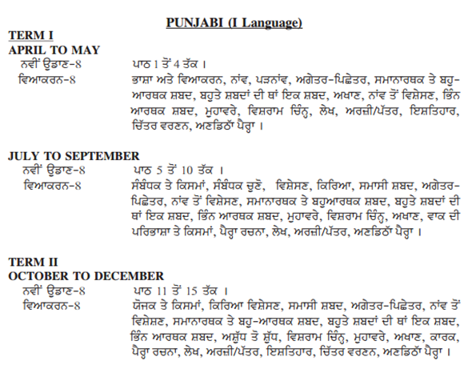
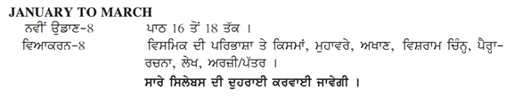
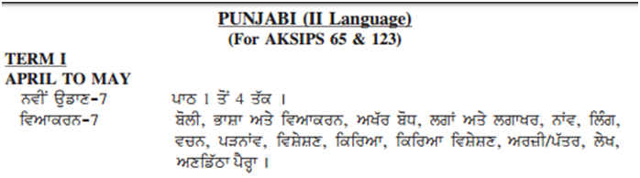
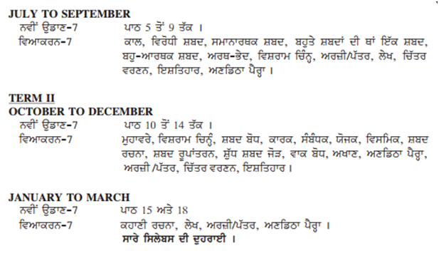

Computer
TERM –I
APRIL TO MAY
1. Computer Network
2. Access – Tables & Forms

JULY TO SEPTEMBER
3. Access – Query & Report
4. HTML – Form Multimedia & CSS
5. Cloud Computing

TERM –II
OCTOBER TO DECEMBER
6. E – Commerce & Blogging
7. Artificial Intelligence
8. App Development

JANUARY TO MARCH
9. Python - Introduction
10 Python – Control Structures

